**OOt'IU"\fl (letter)**

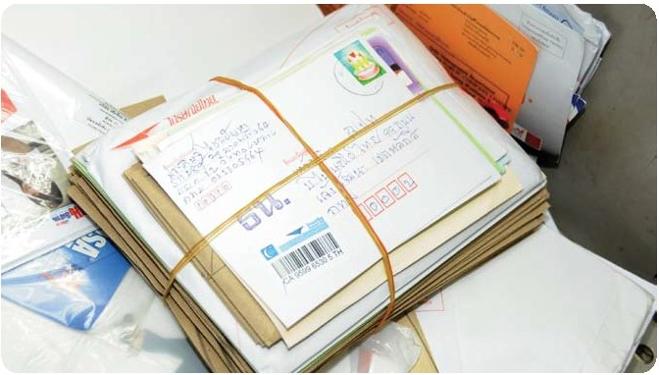

WDOU8ms

tnt!ud111h1ml'h1IK1w!mlr:un,q,Mali'u l11!JU'Wtuh!ol'IUIINlln ,J,fflltlgo ,iullltu 2 !!Tun uermn1l

A'l'll11111'11si1atffKntifll::LOu1ulun,::111mlluu11a::«u10vnoo™ulh t'l'ltfu•f!t1lutl1at1-r.:,,i111ffut!ulfo1111Un

1m U'nffll111mL'1SIL !Jlr.h 'lflffll1ll810111' (Aerogramme)

tl}ll.•llatiU'IQ

**e** 'IIOl'M'f'llllflll'l'ffl1!8lh1 1'1'l'l'

**e** W11l8tnOi1(tmd x Im) 9 x 14 ,ni.

• w1,ie!h0Qi1 (n'ho x vn) 30 x 60 ini.



• n1"N *un* IIC'IM 'rnlullilu 90 1111.

• ,'J,fflliluJlllu 2 1'lliln,ai



....,.



•wll"llil'ummT11D11lll'nldl611.11:blllu'f111'M,nllll

•• *'llr.:in*llll'ffl'lllrrm.hnlk1\h.la,!lll'lll 'llt\l'l:mll'li'llle,H'lll